Chapters 3 & 4
Study Problems
3-5. (Working with an income statement and balance sheet) Prepare a balance sheet and income statement for Belmond, Inc. from the following information.

Income Statement Balance Sheet
Sales $12,800 | Cash $16,550
Cost of goods sold $5,750 | Accounts Receivable $9,600
Gross Profit $7,050 | Inventory $6,500
Operating expenses $1,350 | Total Current Assets $32,650
Depreciation expenses $500
Operating Income $5,200 | Buildings and equipment $122,000
General Admin expenses $850 | Accumulated depreciation $34,000
Interest expenses $900 | Total Assets $120,650
Taxes $1,440
Net Total $2,010 | Accounts Payable $4,800
 | Short term notes payable $600
 | Total Current Liabilities $5,400
 | Long Term debt $55,000
 | Total Liabilities $60,400
 | Common Stock $45,000
Assets = Liabilities + common stock = | Retained Earnings $15,250

3-9. (Analyzing a statement of cash flows) Interpret the following information regarding Westlake Corporation’s cash flows.

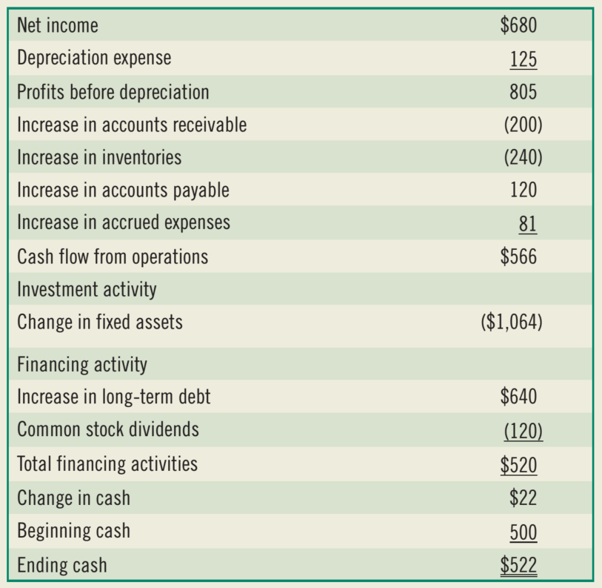

4-9. (Ratio analysis) The financial statements and industry norms are shown below for Pamplin, Inc.:
- Compute the financial ratios for Pamplin for 2014 and for 2015 to compare both against the industry norms.
- How liquid is the firm?
- Areitsmanagersgeneratinganadequateoperatingprofitonthefirm’sassets?
- How is the firm financing its assets?
- Are its managers generating a good return on equity?

